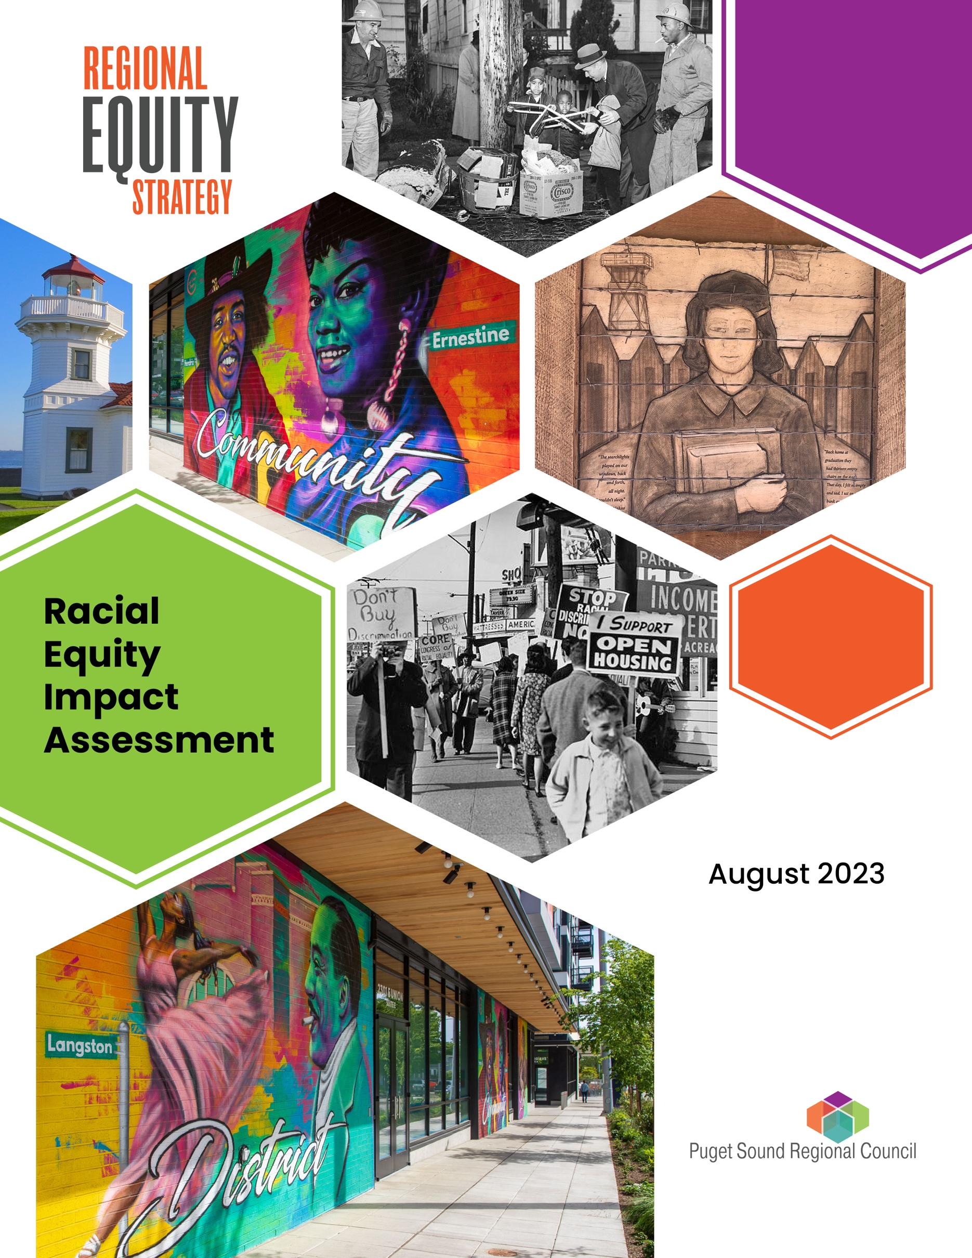**­**

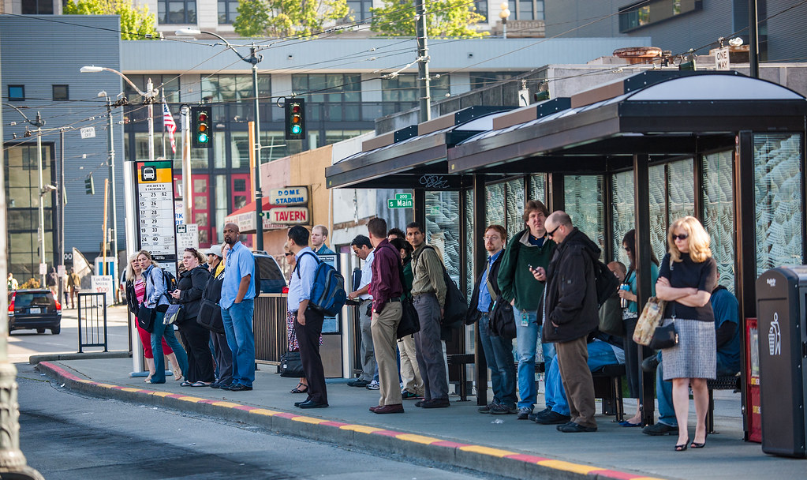

Cover Image Credits

* Cherry Hill Clean Up Campaign, December 8, 1959. Courtesy of the Seattle Municipal Archives, ID 77421.
* CORE-sponsored demonstration at realtor office of Picture Floor Plans, Inc., May 4, 1964. Courtesy of the Seattle Municipal Archives, ID 63893.

**American with Disabilities Act (ADA) Information**

Individuals requiring reasonable accommodations may request written materials in alternate formats, sign language interpreters, physical accessibility accommodations or other reasonable accommodations by contacting the ADA Coordinator, Thu Le, at 206-464-6175, with two weeks’ advance notice. Persons who are deaf or hard of hearing may contact the ADA Coordinator, Thu Le, through TTY Relay 711.

**Title VI Notice**

PSRC fully complies with Title VI of the Civil Rights Act of 1964 and related statutes and regulations in all programs and activities. For more information, or to obtain a Title VI Complaint Form, visit https://www.psrc.org/about-us/title-vi.

**Language Assistance**

العربية (Arabic), 中文 (Chinese), Deutsch (German), Français (French), 한국 (Korean), Русский

(Russian), Español (Spanish), Tagalog, Tiếng việt (Vietnamese)

For language assistance, visit <https://www.psrc.org/contact-center/language-assistance>.

Additional copies of this document may be obtained by contacting:

Puget Sound Regional Council, Information Center, 1011 Western Avenue, Suite 500,

Seattle, Washington 98104-1035 | 206.464.7532 | [info@psrc.org](mailto:info@psrc.org) | [www.psrc.org](http://www.psrc.org/)



## Acknowledgments

This Racial Equity Impact Assessment was developed by the Puget Sound Regional Council (PSRC) and was a collaborative effort between PSRC’s Regional Planning, Growth Management Planning, Transportation Planning and Data groups. It was developed with the input of PSRC’s [Equity Advisory Committee](https://www.psrc.org/committee/equity-advisory-committee-eac). The committee recommended development of the toolkit, provided early input on the design and content of the toolkit, and reviewed and commented on early drafts.

This assessment has been adapted from the Government Alliance on Race and Equity’s (GARE) [Racial Equity Toolkit: An Opportunity to Operationalize Equity](https://www.racialequityalliance.org/resources/racial-equity-toolkit-opportunity-operationalize-equity/). We would also like to acknowledge the toolkits of King County and the cities of Redmond, Seattle and Portland. PSRC also received input from planning staff at WSDOT and the City of Everett.

#### Contributing PSRC Staff:

Josh Brown

Grant Gibson

Sarah Gutschow

Erika Harris

Ben Kahn

Maggie Moore

Charles Patton

Laura Benjamin

Liz Underwood-Bultmann

# Introduction

## The Region's Vision for Racial Equity

Equity is a key part of the central Puget Sound region’s vision for 2050. The central Puget Sound region provides an exceptional quality of life and opportunity for all, connected communities, a spectacular natural environment, and an innovative, thriving economy. More specifically, VISION 2050’s goal for equity states, “All people can attain the resources and opportunities to improve their quality of life and enable them to reach their full potential. Differences in life outcomes cannot be predicted by race, class or any other identity. Communities of color, historically marginalized communities and those affected by poverty are engaged in decision-making processes, planning and policy-making.”

## What Is a Racial Equity Impact Assessment?

Tools such as this Racial Equity Impact Assessment are designed to integrate explicit consideration of racial equity in decisions, including policies, programs and budgets. It is both a product and a process and helps to institutionalize the consideration of racial equity. The assessment provides a guided set of questions to systematically weave equity into policy decisions.

## Why Use a Racial Equity Impact Assessment?

Racial inequities have been an enduring part of public policy in this country. Racial equity impact assessments seek to reduce, eliminate and prevent discrimination and inequities, which are often unconsciously replicated when they are not consciously addressed. These tools can help minimize unanticipated adverse consequences in a variety of public policy and budgeting decisions.

VISION 2050 includes policies and actions that support the dismantling of systemic inequities. The regional plan includes many policies and actions related to equity across plan chapters, and it calls for the centering of equity in local planning work. Local planners are asked to articulate how racial equity is addressed in the plan as part of PSRC plan review through the [VISION 2050 Comprehensive Plan Consistency Tool.](https://www.psrc.org/our-work/plan-review)

Comprehensive plan updates are an important time for cities and counties to work with community members to understand the current and future priorities. This tool is intended to help local jurisdictions use community feedback to identify key issues in their comprehensive plans and apply a racial equity lens to the decisions being made around said issue.

Given the wide-ranging scope of a comprehensive plan, it may be challenging to use a Racial Equity Impact Assessment on the full plan. This assessment tool is intended to be used on key proposals that emerge from the comprehensive plan update process. This tool can be most effective when used to evaluate specific proposals considered during a comprehensive plan update or implementation steps emerging from an adopted plan. Use of this assessment can lead to the development of improved comprehensive plan proposals, strategies and actions that reduce racial inequities and improve success for all groups.

Organizations have taken different approaches to assessing equity on a plan-level. [VISION 2050](https://www.psrc.org/sites/default/files/2022-02/v2050finalseis-appendixh-equity-march2020.pdf) and the [Regional Transportation Plan](https://www.psrc.org/media/5940) both have equity analyses. The City of Redmond has a [checklist](https://www.redmond.gov/DocumentCenter/View/19917/Themes-20-Report---July-2021) to assess equity and inclusion, sustainability, and resiliency. More discussion of plan-level equity analyses is available in PSRC’s [Equity Planning Resources for Comprehensive Plans](https://www.psrc.org/media/7633). This assessment differs in that, instead of reviewing the entire comprehensive plan, updates are informed by priorities identified by marginalized communities.

For example, community members could identify that a new park in their community is important to address in a city’s comprehensive plan but have questions about community benefits and potential for future displacement. The impact review tool could be used to evaluate community feedback, data, and intended and unintended consequences for this proposal to shape decision-making.

This tool helps planners identify key issues for their communities based on engagement and then provides a series of questions and information-gathering techniques to understand potential racial equity implications.

# Using the Racial Equity Impact Assessment

The Racial Equity Impact Assessment has been tailored for use by city and county staff in updating comprehensive plans. However, it could be further tailored for other types of plans and decision making. Community partners who are providing input on the comprehensive plan could also fill out this assessment.

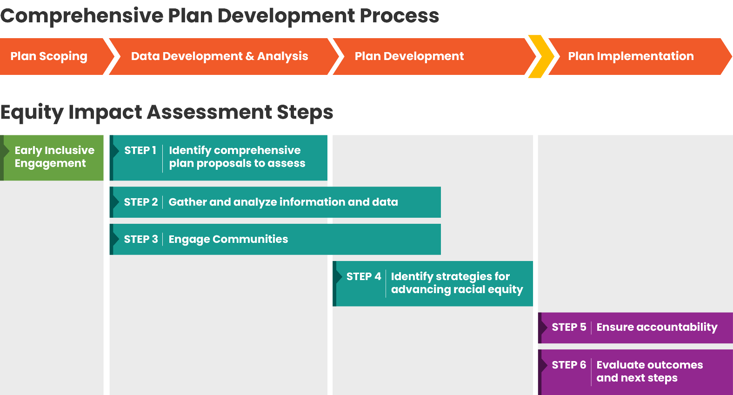

This tool should be used throughout the planning process and can be returned to during different phases as more materials are gathered. Following initial community engagement is a good opportunity to start this process by identifying key issues from these conversations and diving further into how they may impact racial equity.

The information below describes the timing for completing each step of the assessment. The first part of the assessment should be shared with the public and decision makers during development of the comprehensive plan, well before the plan is adopted, such as during the formal public comment period. This allows the assessment to be integrated into the draft plan materials and community engagement process and gives decision makers time to consider the proposals, positive and negative impacts, and strategies. Note that community engagement specific to this assessment must occur before the questions in Step 3 can be answered. Users are encouraged to return to earlier steps and repeat the process as needed to achieve desired outcomes.

# Racial Equity Impact Assessment Checklist

Complete the worksheet for each proposal to be assessed. Use the checklist below to keep track of your progress using the Racial Equity Impact Assessment. See the guidance and resources for each step for additional information.

* Early inclusive engagement. Conduct inclusive community engagement before completing the assessment, preferably before the comprehensive plan update process begins, in order to identify key issues to address in the plan.
* Step 1: Identify comprehensive plan proposals to assess**.** Select the policies, programs, or other elements of the comprehensive plan to include in the assessment, with consideration of input from the early engagement. Identify desired outcomes.
* Step 2: Gather and analyze information and data. Once the proposals are identified, use qualitative and quantitative data to identify and analyze potential impacts to underserved communities.
* Step 3: Engage communities. Once the proposals are identified, engage the community to learn about potential impacts of the proposal. Completing Step 2 may inform the communities to engage with in Step 3.
* Step 4: Identify strategies for advancing racial equity. After Steps 2 and 3 are complete, look for potential unintended consequences, identify strategies to reduce disparate impacts and find opportunities to partner.
* Step 5: Ensure accountability and communicate. Shortly after the comprehensive plan is adopted, consider how to ensure implementation of the strategies identified in Step 4, including communication strategies and ongoing engagement.
* Step 6: Evaluate outcomes and next steps.During and after proposal implementation, evaluate whether you are achieving the anticipated outcomes. Adjust actions if negative impacts or unintended consequences arise and incorporate findings into plan updates and other work.

# Racial Equity Impact Assessment

## Early inclusive community engagement before completing the Racial Equity Impact Assessment:

## 

### Early Inclusive Engagement Guidance and Resources

Community input is key to successfully conducting a Racial Equity Impact Assessment, so identifying marginalized groups and affected communities and conducting inclusive engagement is an important preliminary step. This could be integrated into other efforts to build relationships with communities. This early step can help to identify issues to address in the comprehensive plan, such as increasing affordable housing, providing equitable access to parks and open space, and improving transportation safety. Build in adequate funding for community engagement early in the comprehensive plan update process.

### Resources

* PSRC's [Equitable Engagement for Comprehensive Plans](https://www.psrc.org/media/5933)
* PSRC example: [Outreach Compensation Policy and Procedures](https://www.psrc.org/media/6867)

### What early inclusive community engagement work has been conducted?

*Response:*

### What key issues have emerged from this community engagement?

*Response:*

## Step 1: Identify comprehensive plan proposals to assess and describe their desired outcomes.

### Step 1 Guidance and Resources

Clearly describe the policies, programs or other elements of the comprehensive plan to analyze in the Racial Equity Impact Assessment. These are referred to as “proposals” for brevity. Early inclusive community engagement will help to identify the proposals. Proposals could be assessed for whether they have fewer benefits or greater negative impacts on communities of color, low-income communities and other marginalized groups. Research and analysis can also help to identify proposals that may have equity implications. Types of proposals to assess include planning for substantial development or change in a neighborhood, new or updated policies, new major projects or other important changes. Some comprehensive plan proposals that could have equity implications or disparate effects, such as displacement, include land use changes and center designations, transportation improvements, new and renovated parks, and technology investments. A proposal could be an effort to advance racial equity that you want to assess for the likelihood it will result in the intended outcomes.

Select the proposals of greatest importance to the community to assess as part of the comprehensive plan periodic update. Fill out an assessment worksheet for each proposal separately. Share the draft list and confirm the issues to assess and solicit input for Step 3 as part of early community engagement work, such as scoping.

### Resources to help identify proposals to assess that may have negative equity impacts:

* PolicyLink [All-in Cities Policy Toolkit](https://allincities.org/toolkit) (list of policy tools to advance racial equity)
* PSRC’s [Displacement Risk Mapping](https://www.psrc.org/our-work/displacement-risk-mapping) and [List of Indicators](https://www.psrc.org/media/2749)
* PSRC’s [Opportunity Mapping](https://www.psrc.org/our-work/opportunity-mapping) and [List of Indicators](https://www.psrc.org/media/6434)
* PSRC’s [Equity Planning Resources for Comprehensive Plans](https://www.psrc.org/media/7633)
* Urban Displacement Project’s [research on displacement and gentrification](https://www.urbandisplacement.org/about/what-are-gentrification-and-displacement/)
* To differentiate shorter and longer-term outcomes, see the Center for Theory of Change’s [article on identifying long-term goals/outcomes](https://www.theoryofchange.org/what-is-theory-of-change/how-does-theory-of-change-work/example/outcomes/).

## For each proposal:

### 1.1: What policy, program or other element of the comprehensive plan (proposal) is being analyzed in the Racial Equity Impact Assessment and how was the proposal selected?

### 

*Response:*

### 1.2: What are the intended short-term and long-term outcomes of the proposal?

*Response:*

## Step 2: Gather and analyze information and data.

### Step 2 Guidance and Resources

After identifying comprehensive plan proposals to assess, gather data relevant to each proposal. Types of quantitative data that can help inform the assessment are listed below.

* [Demographic data](https://psrcwa.shinyapps.io/community-profiles/) to identify the race, income, ability-status and other characteristics of people living in an affected area
* [Transportation data](https://psrcwa.shinyapps.io/community-profiles/) to identify modes of travel, car ownership and transit access
* [Housing data](https://psrcwa.shinyapps.io/community-profiles/) to identify housing cost burden and homeownership disparities
* [Parks data](https://www.tpl.org/parkscore) to identify gaps in access to parks and open space
* [Health data](https://doh.wa.gov/data-and-statistical-reports/washington-tracking-network-wtn/washington-environmental-health-disparities-map) to identify health disparities
* [Displacement risk data](https://www.psrc.org/our-work/displacement-risk-mapping) to identify areas with higher or lower risk of displacement

Qualitative information can complement findings from quantitative data analyses. With the data gathered, complete the questions for each proposal.

### Resources:

* Legacy of Structural Racism StoryMap (coming soon)
* Equity Tracker (coming soon)
* PSRC [data resources](https://www.psrc.org/our-work/data), also see list above
* PSRC’s [Equity Planning Resources for Comprehensive Plans](https://www.psrc.org/media/7633)
* PSRC’s [Community Profiles](https://psrcwa.shinyapps.io/community-profiles/)

2.1: What are likely benefits and impacts (short-term and long-term) the comprehensive plan proposal will have in specific geographic areas (neighborhoods, areas or regions)?

*Response:*

### 2.2: What are the racial demographics of the area affected by the proposal?

*Response:*

### 2.3: How has structural racism impacted the community? (See the interactive report on the legacy of structural racism.) What does data show you about how these inequities persist in the community?

*Response:*

### 2.4: What gaps exist in the data? If needed, how can you obtain additional information for analyzing the proposal?

*Response:*

## Step 3: Engage communities.

### Step 3 Guidance and Resources

If not already completed, conduct community engagement to help answer the questions below for each proposal. To focus engagement, refer to the disparities identified in earlier steps and the communities that appear to be most marginalized. Local Tribes may also want to be a part of the planning and assessment process. Ask the community about the benefits and burdens of the comprehensive plan proposals and confirm that the assessment is including the most important proposals.

### Resources:

* PSRC's [Equitable Engagement for Comprehensive Plans](https://www.psrc.org/media/5933)
* PSRC’s [Coordination with Tribes in Comprehensive Planning](https://www.psrc.org/media/5950)

### 3.1: Reflecting on Step 2, which communities have been the most marginalized and will likely be most impacted by the comprehensive plan proposal? How have you involved them in the development of the comprehensive plan?

*Response:*

### 3.2: What has your engagement process and the lived experience of community members told you about the proposal’s burdens, benefits or unintended consequences for different groups?

### 

*Response:*

### 3.3: Which affected communities were not involved in the development of the proposal? What barriers limited your engagement with these groups and how can this be addressed in the future?

*Response:*

### 3.4: Are there other issues to which the community thinks the Racial Equity Impact Assessment should be applied?

*Response:*

## Step 4: Identify strategies for advancing racial equity.

### Step 4 Guidance and Resources

After completing Steps 2 and 3, answer the questions below for each comprehensive plan proposal using the findings from your research and community engagement. **After developing potential strategies, you are encouraged to share them with affected communities and seek further development. This may require returning to previous steps.** Unintended consequences are negative outcomes that are not foreseen. Because they are difficult to foresee, the ability to monitor and adjust is important. You may be able to accelerate positive change by building on the work of other agencies and partners.

### Resources:

* PSRC [Regional Housing Strategy](https://psrc.org/regional-housing-strategy) and [Housing Innovations Program](https://psrc.org/hip)
* PSRC’s [Equity Planning Resources for Comprehensive Plans](https://www.psrc.org/media/7633)
* PSRC [Equity Resources](https://psrc.org/equity)
* PolicyLink [Anti-displacement Tools](https://www.policylink.org/resources-tools/ADPN-lessons)
* Puget Sound Sage [Equitable Development Programs](https://www.pugetsoundsage.org/programs/equitable-development/)
* Article: [Unintended Consequences: Minimizing The 'Oops Factor' In Decision Making](https://www.forbes.com/sites/rodgerdeanduncan/2015/06/22/unintended-consequences-minimizing-the-oops-factor-in-decision-making/?sh=63bb4878671b)

### 4.1: What are potential strategies for reducing or mitigating the disparities identified for the comprehensive plan proposal and how will they be implemented? Fill In the table below.

|  |  |  |  |  |
| --- | --- | --- | --- | --- |
| Strategy | Action/Task | Staff Responsible | Deadline | Resources Needed |
|  |  |  |  |  |
|  |  |  |  |  |
|  |  |  |  |  |
|  |  |  |  |  |
|  |  |  |  |  |

### 4.2: What are potential unintended consequences of the strategies identified above? Can the proposal be adjusted if unintended consequences arise?

*Response:*

### 4.3: What are ways in which existing relationships could be strengthened to maximize positive impact in the community? How will you partner with stakeholders and other agencies for long-term positive change?

*Response:*

## Step 5: Ensure accountability and communicate.

### Step 5 Guidance and Resources

Shortly after the comprehensive plan has been adopted, complete Step 5 for each proposal, as applicable. For the strategies identified in Step 4, consider whether they have:

* Adequate funding
* Adequate personnel
* Adequate mechanisms to ensure successful implementation and enforcement
* Adequate resources for on-going data collection, public reporting and community engagement
* Been incorporated into relevant plans and programs

Step 6 is about evaluating outcomes. Question 5.4 asks about planning ahead for this evaluation.

### Resources:

* [Joint Board Session on Affirm, Counter, Transform (ACT): A Guide to Talking about Race:](https://www.psrc.org/boards-committees/upcoming-meetings/meeting/joint-board-session-affirm-counter-transform-act-guide)
* GARE [Communications Guide](https://www.racialequityalliance.org/wp-content/uploads/2018/05/1-052018-GARE-Comms-Guide-v1-1.pdf) (see page 17 for ACT)

### 5.1: How will you work to implement the strategies identified in Step 4?

*Response:*

### 5.2: Are racial equity goals and actions in the comprehensive plan reflected in associated plans and strategies (transportation plan, housing strategy, etc.)?

*Response:*

### 5.3: What messages and communication strategies will help advance racial equity as part of your engagement process?

*Response:*

### 5.4: How will the outcomes, impacts and unintended consequences in Step 6 be evaluated and documented?

*Response:*

## Step 6: Evaluate outcomes and next steps.

### Step 6 Guidance and Resources

Questions 6.1 and 6.2 should be answered during and after proposal implementation.

Next Steps:

* Adjust actions if negative impacts or unintended consequences arise.
* Incorporate findings into plan updates and other work.

### Resources

* [Evaluation Guide for Public Service Program Managers](https://www.urban.org/sites/default/files/publication/103385/evaluation-guide-for-public-service-program-managers.pdf)

### 6.1: Are you achieving the anticipated outcomes? If not, how is this being addressed?

*Response:*

### 6.2: Have there been any unintended consequences? If so, how are these being addressed?

### 

*Response:*

### 6.3: How are you continuing to engage communities and partners and ensure implementation is sustainable?

*Response:*

# Appendix A. Racial Equity Impact Assessment Summary of Steps and Questions

## Early inclusive community engagement before completing the Racial Equity Impact Assessment:

* What early inclusive community engagement work has been conducted?
* What key issues have emerged from this community engagement?

## Step 1: Identify comprehensive plan proposals to assess and describe their desired outcomes.

* 1.1: What policy, program, or other element of the comprehensive plan (proposal) is being analyzed in the Racial Equity Impact Assessment and how was the proposal selected?
* 1.2: What are the intended short-term and long-term outcomes of the proposal?

## Step 2: Gather and analyze information and data.

* 2.1: What are likely benefits and impacts (short-term and long-term) the comprehensive plan proposal will have in specific geographic areas (neighborhoods, areas, or regions)?
* 2.2: What are the racial demographics of the area affected by the proposal?
* 2.3: How has structural racism impacted the community? (See the interactive report on the legacy of structural racism.) What does data show you about how these inequities persist in the community?
* 2.4: What gaps exist in the data? If needed, how can you obtain additional information for analyzing the proposal?

## Step 3: Engage communities.

* 3.1: Reflecting on Step 2, which communities have been the most marginalized and will likely be most impacted by the comprehensive plan proposal? How have you involved them in the development of the comprehensive plan?
* 3.2: What has your engagement process and the lived experience of community members told you about the proposal’s burdens, benefits or unintended consequences for different groups?
* 3.3: Which affected communities were not involved in the development of the proposal? What barriers limited your engagement with these groups and how can this be addressed in the future?
* 3.4: Are there other issues to which the community thinks the Racial Equity Impact Assessment should be applied?

## Step 4: Identify strategies for advancing racial equity.

* 4.1: What are potential strategies for reducing or mitigating the disparities identified for the comprehensive plan proposal, and how will they be implemented?
* 4.2: What are potential unintended consequences of the strategies? Can the proposal be adjusted if unintended consequences arise?
* 4.3: What are ways in which existing relationships could be strengthened to maximize positive impact in the community? How will you partner with stakeholders and other agencies for long-term positive change?

## Step 5: Ensure accountability and communicate.

* 5.1: How will you work to implement the strategies identified in Step 4?
* 5.2: Are racial equity goals and actions in the comprehensive plan reflected in associated plans and strategies (transportation plan, housing strategy, etc.)?
* 5.3: What messages and communication strategies will help advance racial equity as part of your engagement process?
* 5.4: How will the outcomes, impacts and unintended consequences in Step 6 be evaluated and documented?

## Step 6: Evaluate outcomes and next steps.

* 6.1: Are you achieving the anticipated outcomes? If not, how Is this being addressed?
* 6.2: Have there been any unintended consequences? If so, how are these being addressed?
* 6.3: How are you continuing to engage communities and partners and ensure implementation is sustainable?

# Appendix B. Definitions

* Institutional Racism: Policies, practices and procedures that work better for white people than for people of color, often unintentionally.
* Long-term outcomes: Ultimate changes or impacts, directly connected to short-, mid- or other long-term outcomes, typically including social, economic, civic or environmental changes.
* Proposal: Policies, programs or other elements to be considered by decision makers for inclusion in the updated comprehensive plan.
* Racial equity: Race can no longer be used to predict life outcomes and outcomes for all groups are improved.
* Racial inequity: Race can be used to predict life outcomes, such as disproportionality in education (high school graduation rates), jobs (unemployment rate), criminal justice (arrest and incarceration rates), etc.
* Scoping: The process to identify work needed to complete the comprehensive plan and/or environmental review.
* Short-term outcomes: Intended changes directly connected to activities, typically including awareness, knowledge, attitudes and skills; these are the first set of outcomes that might be observed.
* Structural racism: A history and current reality of institutions combining to create a system that negatively impacts communities of color.
* Unintended consequences: Negative outcomes that are not planned or foreseen.